SWE 3313 Intro. to Software Engineering Section 01 Fall Semester 2019 Professor: Richard Gesick

Project Plan Mom & Pop’s Pizza

Team Members: Dylan Sirna, Gabriel Rodriguez, Efren Portugal, Zhuoxing Wang

Table of Contents-Project Plan

Scope 2

Schedule 3

Team Organization 4

Team Roles: 5

Resumes: 6

Technical Description 7

Data Management Plan 8

Test Plan 9

# Scope

We have been asked to design a pizza order and delivery system for Mom & Pop’s pizza shop. This is a brand-new startup operation and the shop is a pickup or delivery business only, there is no restaurant dining option available. We are tasked with setting up the whole computer system for them and below are the major functionalities we plan to implement for this project.

Major functionalities of the project.

1. Set up new customers

* Keep a record of new and old customers
* Information will be keyed by customer phone number
* Master record for each customer contains their name, address, phone, and type of charge account (Visa / Mastercard)
* Record pertinent information for locating the address (i.e., subdivision name, closest major intersection, etc.)

1. Take pizza orders

* For already registered customers their address and billing information should show up

1. Calculate bills

* Print out a receipt of the order with a place to sign the form by the customer if it is on a credit card
* Checkout cart with customer information, a list of items ordered, if it is for delivery or pickup, and total amount due

1. Process payments

* Process payments in the form of checks, cash, or credit cards
* Keep track of the type of payment made and amount

1. Contain restaurant menu

* A GUI interface for the user that shows the complete restaurants menu for order-taking purposes
* The menu will have different options for the customer to customize their order
* They can choose the pizza’s size, crust, and toppings
* Order other menu items like beverages and choose the number of pizzas they want
* The menu GUI interface will utilize dropdown and radio/checkbox buttons for customizing pizzas

# Schedule and Work Breakdown Structure

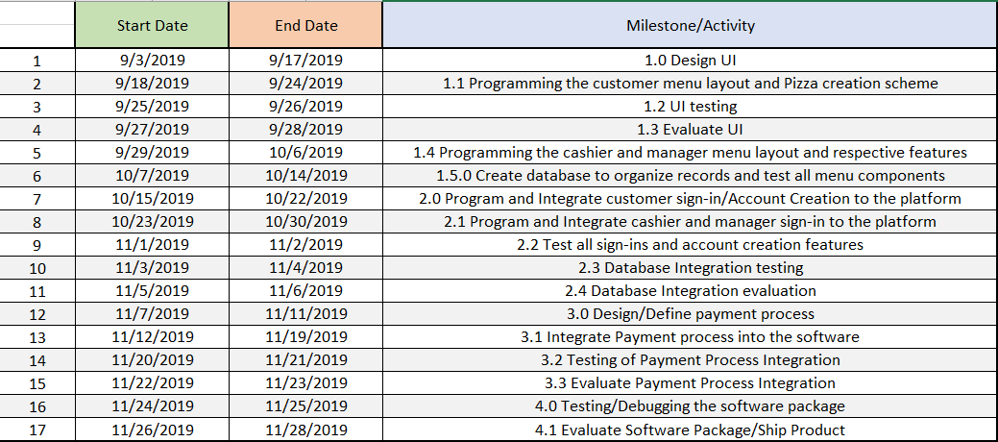

# Milestones

# GANTT Chart

# Team Organization

# Team Roles

**Dylan Sirna:**

* Team Leader
* Project Manager
* Tester, Programmer
* **Gabriel Rodriguez:**
* Lead Programmer
* Lead Designer
* Tester

**Efren Portugal:**

* Lead Document Writer
* File Manager, Programmer
* Tester.

**Zhuoxing Wang:**

* Organizer
* Programmer
* Tester
* Technical and Graph Provider

# Resumes



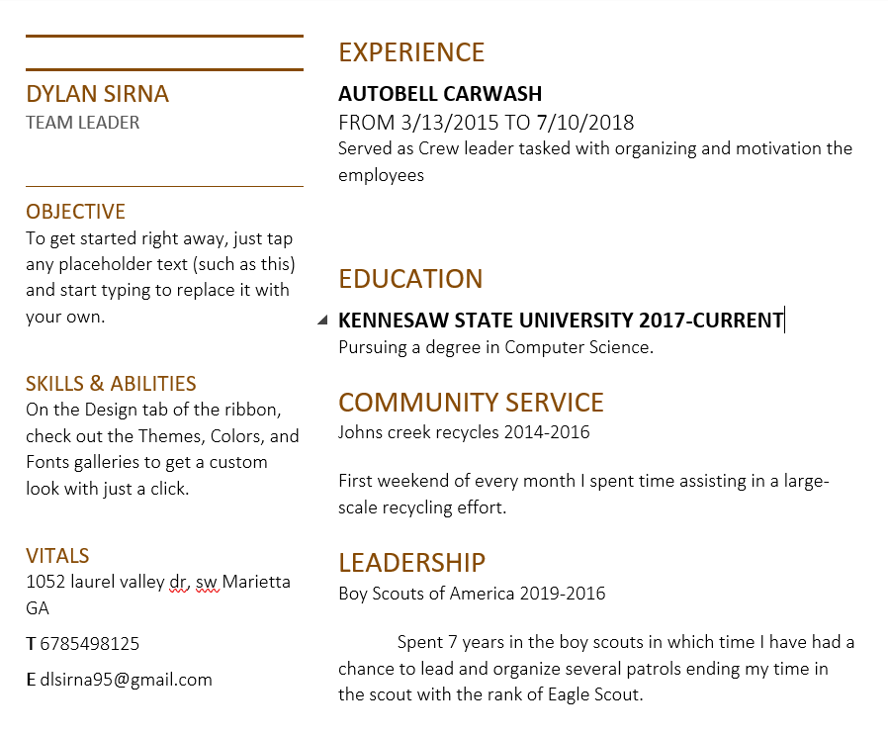

Experience

Gabriel Rodriguez

## Contact

**Nationality:** Nicaraguan

**Location:** U.S

**Mobile:** (404) 917-4294

**Email:** [gabo-rodriguez@hotmail.com](mailto:gabo-rodriguez@hotmail.com)

## Skills

**Database Management**

* SQL, MYSQL

**Programming Languages**

* Proficient: JAVA
* Familiar: C, PHP, HTML/CSS, VISUAL BASIC

**Game Development**: Unreal Engine 4 – Blueprints programming.

**Statistical Operations:** SPSS

- No previous business labor experience related to this field.

Education

**Kennesaw State University, U.S**

Major: Software Engineering Current GPA: 3.57

Programming Course Work: Programming and Problem Solving 1 and 2

Status: Currently enrolled as an international transfer student since January 7, 2019

**American University (UAM), Nicaragua**

Major: Systems Engineering

Programming Course Work: Algorithms and Data Systems, Structured Methodology and Programming, Object Oriented Programming 1 and 2, Analysis and Object-Oriented Design, Operative Systems, Programming Languages, Database Theory, Database Management.

Status: Attended from February 2016 to November 2018

Certificate of completion of the course “IT Essentials” of **CISCO Networking Academy** – 2016

Other

**Play Store android developer as a hobby**, under the name of “Sense Games” – August 2018 until the present time.

Participation in representation of the American University (UAM), in the **National Hackathon** promoted by the National Council of Universities (CNU), National Technological Institute (INATEC), and the Ministry of Education (MINED). – December 2017.

**1st Place -** **Mobile Applications Youth Contest** of the Nicaragua Council of Science and Technology (CONICYT), entertainment category, with the game “Neon Run”, for the android platform. – October 2017.

# Technical Description

The system consists of two modules that divide the features needed in different screens. The first module is the customer module, which enables the users to create an account, login, edit their information, and make any order they want. The second module is the manager module, which enables the manager to edit menu prices and generate reports. Now we will describe the different screens and provide more detail of each one.

Module 1 – Customer Module Components:

* Customer Login: In this screen the customer can login with their account or as guest and create an account if they are not registered yet.
* Customer Logged-In Menu**:** This screen is the main menu of the software for logged-in customers. Customer can select any item from the menu to start customizing the pizza from scratch.
* Customer Guest Menu: This screen is the main menu of the software for guest customers. Customer can select any item from the menu to start customizing the pizza from scratch.
* Customer Logged-In Account Configuration: In this screen users can edit all their information: name, phone number, address, cardholder name, card number, expiration date, security code, type of card, and password.
* Selection Screen: This screen is the main tool for customizing the order in terms of pizza basics, meats, and non-meats. The users will be able to navigate all the options for size, crust, and toppings of the pizza, by using the navigation buttons: Basics, Meats, Non-Meats. Also, the user will be able to add/remove from Cart the different pizzas.
* DS (Drinks, Sides):This screen is the main tool for customizing the order in terms of drinks and sides. The users will be able to navigate all the options for drinks and sides of the order, by using the navigation buttons: Drinks, Sides. Also, the user will be able add/remove from Cart the drinks and sides.
* Customer Logged-In Confirmation Screen: In this screen the user can see all the items in Cart, the client information, choose between delivery and pickup, and choose a Payment Method (Cash, Card). Also, the user can remove items from the Cart. A receipt will be printed when the order is registered.
* Customer Guest Confirmation Screen: In this screen the user can see all the items in Cart, the client information, choose between delivery and pickup, and choose a Payment Method (Cash, Card, Check). Also, the user can remove items from the Cart and input any missing required information. A receipt will be printed when the order is registered.

Module 2 – Manager and Cashier Module Components:

* Administration Login: In this screen the manager can login.
* Manager Menu: In this screen the manager can generate reports and edit the prices of pizzas, drinks, and sides on the menu.

# Data Management Plan

Project: Pizza Order and Delivery System

1. Description of the Data

1.1 Type of Data

Details of all registered users and detailed menu data.

1.2 Details of User’s Data

Name, Address, Phone Number, Payment Information, Payment Method (Card, Cash, Check), and Logistic (Pick up/ Delivery).

1.3 Details of Menu Data

Pizza basics (size, crust) meats, non-meats, drinks, and sides.

1.3 Format and Scale of Data

For every new user registered in our application, his/her detailed information must generate a registry in the respective database fields. His/her information (include 1.2) must be saved and kept secret.

2. Data Management and Dissemination Management

2.1 Data confidentiality

User's information and data cannot be disclosed. Apart from staff and messengers, the contact information and address of the customer should not be disclosed to others. Only users have the right to check and change their data especially because of the payment information.

2.2 Application of User’s Data

When the registered user completes an order, according to the user's information and data, the staff will receive the user's detailed ordering requirements and contact details.

2.3 Application of Menu Data

Real-time updates are required, and all current prices are displayed to users.

# Test Plan

This is the test plan for the development of the delivery and pickup software for Mom & Pops Restaurant. The system contains many input fields and selections when registering, login in, customizing the pizza, ordering drinks or dessert, and when confirming the purchase. All these fields will be tested to ensure that all exceptions are handled.

Each member from the development team will contribute to test some components. We will prepare cases for each possible exception and preconditions to make each test more specific. Each case will be tested at least 2 times to ensure that we don’t miss an error by mistake. The person in charge of a certain component is responsible for testing all the required cases of that component and recording the results. Nevertheless, when merging the different components for a release, we, as a team, will conduct a group testing of all the components together to identify any relationship errors. We will also test if the data is correctly inserted into the database, and how long it would take to search and find information when dealing with a high number of registries.

The criteria for terminating testing is having 98% of errors tested and resolved and the other 2% not being any deathly or frequent errors that make the software unfunctional.

A sample of the table we will be using to record the results of the test has the following:

* Test Scenario: Describes the functionality we are testing.
* Test Case: Describes the case we are testing of the functionality.
* Pre-Conditions: Describes any prior requirements we assume are met for the functionality to be successful.
* Test Data: Describes the data examples that we will use to meet the case we are testing.
* Expected Result: Describes what we think will be the outcome of the functionality.
* Actual Result: Describes what was the actual outcome of the functionality.
* Pass/Fail: Here we specify if the testing case was a success or failure.

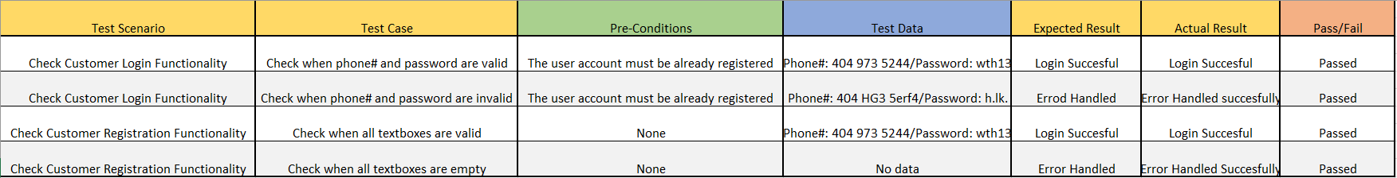The following is an example of how a results table for testing a component will be used: